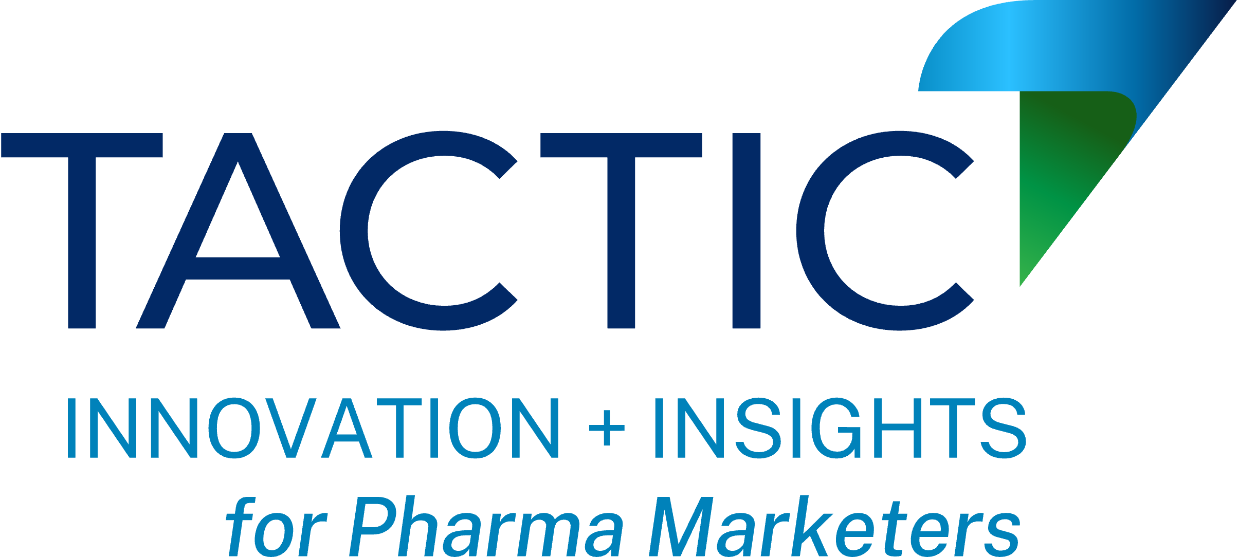

**Subject:** Request for Approval to Attend Tactic 2025

Dear *[Your Boss’ Name]*,

I’m seeking approval to attend [**Tactic 2025**](https://brandtactic.us)**, September 15-17, in Boca Raton, FL**. This event provides a one-of-a-kind opportunity to gain cutting-edge marketing insights tailored to the pharmaceutical industry.

**Why Attend?**

Tactic 2025 is the only conference where top pharma marketing agencies take the stage, offering:

* + **Actionable Insights:** Over 50 presentations and three parallel tracks focused on pharma marketing trends.
  + **Strategic Networking:** Exclusive 1:1 meetings with leading agencies and innovative companies.
  + **Competitive Edge:** Learn directly from the experts shaping our industry’s future.

Registering by June 1 offers savings of up to $500, with additional discounts available for team registrations. Bringing more team members to the event will enhance our brand planning efforts and maximize the value of our participation.

After the event, I’ll share key takeaways, actionable ideas, and strategic opportunities to enhance our current and future plans. The value gained from this event far outweighs the cost and positions us for continued success.

I appreciate your consideration. Please let me know if you’d like to discuss further.

Best regards,

*[Your Name]*